Unit 5
Data Management and Business Intelligence
(4 Hours)

5.1 Importance of data in decision-making
5.2 Data warehousing and data mining
5.3 Business intelligence tools and techniques
5.4 Big data analytics and its business applications

Objectives:
- Analyze how databases can be used for competitive advantage.
- Understand the relationship between business strategy IS strategy and business intelligence

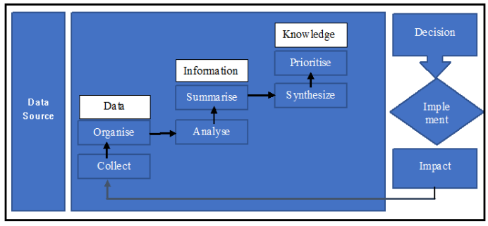
5.1 Importance of data in decision-making

In Management Information System, raw data is collected from different business sources. Then it is organized, analyzed, summarized, synthesized, and prioritized. Finally, managers use it to make decisions. After implementation, the impact is again observed and sent back as feedback for future decisions.

Data
Data means raw facts, figures, and observations collected from business activities.
Data-Driven Decision-Making (DDDM) is the process of using verified facts, metrics, and data analysis to guide strategic decisions rather than relying purely on intuition or guesswork.
It enables organizations to minimize risk, reduce personal bias, and identify new operational opportunities
1. Meaning of Data in MIS
Data means raw facts collected from business operations.
Example:
Data Source | Raw Data
Sales system | Daily sales amount
HR system | Staff attendance
Inventory system | Stock quantity
Finance system | Expenses and income
Customer system | Complaints and feedback
Website/App | Clicks, orders, reviews
Raw data itself may not directly support decision-making. It must be processed.

2. Explanation of the Diagram
Step 1: Data Source
Data source is the place where data is generated.
Examples:
Data Source | Example
POS billing system | Sales bills
College MIS | Attendance and marks
Hospital MIS | Patient records
Banking system | Transaction records
E-commerce website | Orders and clicks

Step 2: Collect Data
The first MIS activity is to collect data from different sources.
Example in a retail store:
Date | Product | Quantity Sold | Unit Price
1 Jan | Laptop | 3 | 70,000
1 Jan | Mouse | 20 | 700
1 Jan | Keyboard | 10 | 1,200
This is raw sales data.

Step 3: Organize Data
Collected data must be arranged properly.
Example:
Instead of random records, MIS organizes data by:
Date | Branch | Product | Category | Quantity | Price
1 Jan | Butwal | Laptop | Computer | 3 | 70,000
1 Jan | Butwal | Mouse | Accessory | 20 | 700
1 Jan | Bhairahawa | Keyboard | Accessory | 10 | 1,200
Organized data is easier to search, filter, and analyze.

Step 4: Analyze Data
Analysis means finding meaning, pattern, or relationship from data.
Add calculated column:
Product | Quantity | Unit Price | Sales
Laptop | 3 | 70,000 | 210,000
Mouse | 20 | 700 | 14,000
Keyboard | 10 | 1,200 | 12,000
Analysis:
- Laptop has the highest revenue.
- Mouse has the highest quantity sold.
- Accessories sell frequently but give lower revenue.

Step 5: Summarize Information
After analysis, MIS summarizes data into useful information.
Category | Total Sales
Computer | 210,000
Accessory | 26,000
Now the manager can quickly understand performance.
This is information, not just raw data.

Step 6: Synthesize Knowledge
Synthesis means combining different information to create deeper understanding.
Example:
Information | Knowledge
Laptop gives high revenue | Premium products are important
Mouse sells in high quantity | Accessories have high demand
Accessory sales are frequent | Bundle offer can increase sales
Knowledge:
Customers buying laptops may also need mouse, keyboard, bag, and antivirus.

Step 7: Prioritize Knowledge
Managers must decide which issue is more important.
Example:
Issue | Importance | Priority
Laptop stock is low | High revenue product | High
Mouse stock is low | High quantity product | Medium
Keyboard sales are low | Less urgent | Low
MIS helps managers focus on important business issues first.

Step 8: Decision
Based on knowledge, management makes decisions.
Example decisions:
- Increase laptop stock.
- Create laptop + mouse + keyboard bundle.
- Give discount on slow-moving keyboard.
- Target corporate customers for laptop sales.

Step 9: Implementation
Decision must be applied in real business.
Example:
Decision | Implementation
Increase laptop stock | Order 20 more laptops
Bundle offer | Laptop + mouse + bag package
Promote accessories | Display accessories near billing counter
Target corporate buyers | Send quotation to offices

Step 10: Impact
After implementation, MIS measures impact.
Indicator | Before Decision | After Decision
Laptop sales | 3 units/day | 5 units/day
Accessory sales | Rs. 26,000/day | Rs. 45,000/day
Customer satisfaction | 75% | 88%
Profit | Rs. 40,000/day | Rs. 65,000/day
If the impact is positive, the decision was successful.
If the impact is negative, management must revise the decision.

Step 11: Feedback
The impact becomes new data for future decisions.
Example:
After bundle offer, accessory sales increased. This result becomes new feedback.
So MIS decision-making is a continuous cycle:
Data → Information → Knowledge → Decision → Action → Impact → Feedback → Better Decision

Example 1: College MIS Decision-Making
A college uses MIS to manage students.
Raw Data
Student | Attendance % | Assignment Score | Internal Marks | Fee Status
Ram | 92 | 18 | 35 | Paid
Sita | 65 | 12 | 24 | Due
Hari | 78 | 15 | 30 | Paid
Gita | 55 | 8 | 18 | Due
Nabin | 88 | 17 | 34 | Paid
Analysis
Student | Risk Level | Reason
Ram | Low | Good attendance and marks
Sita | Medium | Low attendance, fee due
Hari | Low | Acceptable performance
Gita | High | Low attendance, low marks, fee due
Nabin | Low | Good performance
MIS Information
- 2 students have attendance problems.
- 1 student is at high academic risk.
- 2 students have fee dues.
- Low attendance is related to low internal marks.
Management Decision
Problem | Decision
Low attendance | Call student and parents
Low internal marks | Provide extra tutorial class
Fee due | Send reminder notice
High-risk student | Academic counseling
Impact
Indicator | Before | After
Average attendance | 75.6% | 84%
Assignment submission | 70% | 90%
Internal pass rate | 80% | 95%
This shows how MIS supports academic decision-making.

4. Example 2: Hospital MIS Decision-Making
A hospital collects patient flow data.
Raw Data
Department | Daily Patients | Average Waiting Time | Doctors Available
OPD | 180 | 90 min | 3
Emergency | 60 | 20 min | 4
Lab | 120 | 70 min | 2
Pharmacy | 200 | 50 min | 2
Analysis
Department | Problem
OPD | High patient load and long waiting time
Lab | Long waiting time
Pharmacy | Many patients but few counters
MIS Information
- OPD has the highest waiting time.
- Pharmacy has highest service volume.
- Lab needs faster reporting.
- Staff allocation is not balanced.
Decision
Issue | Decision
OPD waiting time high | Add one doctor during peak hours
Lab delay | Add one lab technician
Pharmacy queue long | Open one extra billing counter
Patient dissatisfaction | Display token system
Impact
Indicator | Before | After
OPD waiting time | 90 min | 45 min
Lab waiting time | 70 min | 35 min
Pharmacy waiting time | 50 min | 25 min
Patient satisfaction | 68% | 86%
MIS helps hospital management improve service quality.

5. Example 3: E-Commerce MIS Decision-Making
An online store collects customer behavior data.
Raw Data
Customer | Page Views | Added to Cart | Purchased | Amount
C1 | 12 | Yes | Yes | 4,500
C2 | 9 | Yes | No | 0
C3 | 20 | Yes | Yes | 8,000
C4 | 5 | No | No | 0
C5 | 15 | Yes | No | 0
Analysis
Metric | Value
Total visitors | 5
Added to cart | 4
Purchased | 2
Cart abandonment | 2
Conversion rate | 40%
MIS Information
- Many customers add products to cart but do not buy.
- Cart abandonment is high.
- Customers with high page views are more interested.
- Checkout process may be difficult.
Decision
Problem | Decision
Cart abandonment | Send reminder message
Low conversion | Offer 5% discount
Checkout issue | Simplify payment process
Interested customers | Retarget through ads
Impact
Indicator | Before | After
Conversion rate | 40% | 55%
Cart abandonment | 50% | 30%
Sales | Rs. 12,500 | Rs. 22,000

6. Example 4: Inventory MIS Decision-Making
A shop maintains inventory data.
Raw Data
Product | Current Stock | Monthly Demand | Reorder Level
Rice | 100 kg | 300 kg | 80 kg
Oil | 40 liter | 200 liter | 60 liter
Sugar | 90 kg | 150 kg | 50 kg
Tea | 25 kg | 100 kg | 40 kg
Analysis
Product | Status
Rice | Safe
Oil | Reorder needed
Sugar | Safe
Tea | Reorder needed
MIS Information
- Oil stock is below reorder level.
- Tea stock is below reorder level.
- Rice and sugar stock are enough.
Decision
Product | Action
Oil | Order 200 liters
Tea | Order 100 kg
Rice | No immediate order
Sugar | No immediate order
Impact
- Stock-out is avoided.
- Customer demand is fulfilled.
- Emergency purchase cost is reduced.
- Inventory planning improves.

5.2 Data warehousing and data mining

A. Data Warehousing
1. Meaning of Data Warehouse
A data warehouse is a central storage system where data from different departments or systems is collected, cleaned, integrated, and stored for analysis and reporting.
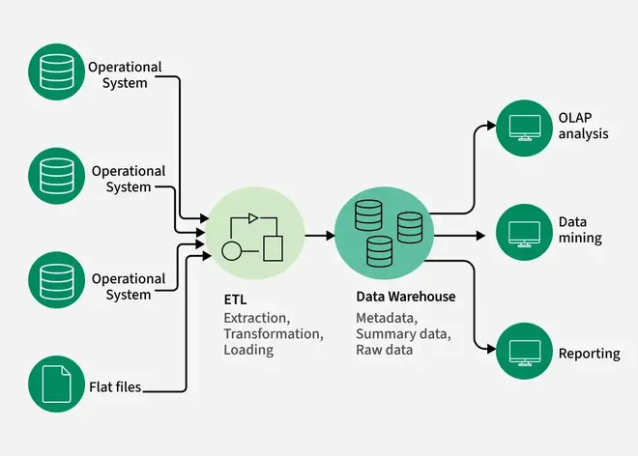
Simple Definition
A data warehouse is a large, centralized database that stores historical and integrated data from different sources to support managerial decision-making.
Example:
A college has different systems:
System | Data
Admission system | Student profile, entrance score
Attendance system | Class attendance
Exam system | Marks, grades
Finance system | Fee paid, fee due
LMS system | Login, assignment, quiz activity
A data warehouse combines all these data into one place so management can analyze student performance, fee collection, dropout risk, and academic quality.

2. Why Data Warehouse Is Needed
In many organizations, data is scattered in different systems.
Example:
Department | Separate Data Problem
Sales | Sales data in Excel
Finance | Expense data in accounting software
HR | Staff data in HR system
Inventory | Stock data in inventory software
Customer service | Complaints in CRM
If the manager wants a complete business picture, separate systems are not enough.
A data warehouse solves this problem by creating a single integrated data platform.
3. Data Warehouse Process
Data Sources
↓
ETL Process
↓
Data Warehouse
↓
Data Mart
↓
Reports / Dashboard / Analysis
↓
Decision-Making

4. ETL in Data Warehouse
ETL means:
ETL Step | Meaning | Example
Extract | Collect data from different sources | Sales, finance, HR, inventory
Transform | Clean and convert data into standard format | Remove duplicate records
Load | Store cleaned data into warehouse | Load into BI database
The identifies ETL and data integration as important parts of BI architecture, because data must be extracted from operational systems, transformed, and loaded into the warehouse for analysis.

Example of ETL
Raw Data Before Cleaning
Student Name | Phone | Program | Attendance
Ram Thapa | 9847000000 | BCA | 82
R. Thapa | 9847000000 | BCA | 82
Sita KC | 9857000000 | BCSIT | 76
Hari Sharma | 9867000000 | bca | 68
Problems:
- Duplicate record: Ram Thapa and R. Thapa
- Program format inconsistency: BCA and bca
- Attendance below required level for Hari
After Transformation
Student ID | Student Name | Phone | Program | Attendance %
S001 | Ram Thapa | 9847000000 | BCA | 82
S002 | Sita KC | 9857000000 | BCSIT | 76
S003 | Hari Sharma | 9867000000 | BCA | 68
Now data is clean and ready for analysis.

5. Characteristics of Data Warehouse
1. Subject-Oriented
Data warehouse is organized around major subjects.
Examples:
Subject | Data Stored
Sales | product, customer, revenue
Student | attendance, marks, fee
Finance | income, expense, profit
HR | staff, salary, performance

2. Integrated
Data from different sources is combined in one standard format.
Example:
Source | Date Format
Sales system | 05/21/2026
Finance system | 2026-05-21
Excel sheet | 21-May-2026
In the warehouse, all dates are stored in one format:

Standard Date
2026-05-21

3. Time-Variant
A data warehouse stores historical data.
Example:
Year | Sales
2022 | 1,500,000
2023 | 2,000,000
2024 | 2,800,000
2025 | 3,500,000
This helps trend analysis and forecasting.

4. Non-Volatile
Once data is stored in a warehouse, it is usually not changed frequently. It is mainly used for analysis.
Example:
Last year’s sales record is stored permanently for comparison.

6. Data Warehouse vs Operational Database
Basis | Operational Database | Data Warehouse
Purpose | Daily transaction processing | Analysis and decision-making
Users | Staff, operators | Managers, analysts
Data | Current data | Historical data
Operation | Insert, update, delete | Query, report, analyze
Example | Fee payment entry | Fee collection trend report
System Type | OLTP | OLAP

7. OLTP and OLAP
OLTP: Online Transaction Processing
OLTP handles daily transactions.
Examples:
- Billing
- Admission entry
- Fee payment
- Product sale
- Salary entry
OLAP: Online Analytical Processing
OLAP analyzes data from different dimensions.
Examples:
- Sales by month
- Fee collection by program
- Attendance by semester
- Profit by branch
OLTP | OLAP
Transaction focused | Analysis focused
Current data | Historical data
Used by clerks and staff | Used by managers
Example: record a sale | Example: analyze yearly sales

8. Data Mart
A data mart is a smaller part of a data warehouse, focused on a specific department or subject.
The data warehouse may consist of one or more data marts, and a data mart focuses on a single subject or line of business.
Data Mart | Used By
Sales data mart | Sales manager
Finance data mart | Finance manager
HR data mart | HR department
Student performance data mart | Academic coordinator
Inventory data mart | Store manager
Example
A college data warehouse may contain:
College Data Warehouse
├── Admission Data Mart
├── Attendance Data Mart
├── Exam Data Mart
├── Finance Data Mart
└── LMS Data Mart

9. Example: College Data Warehouse
Data Sources
Source | Data
Admission | GPA, entrance score, program
Attendance | attendance percentage
Exam | assignment, internal marks, final marks
Finance | fee paid, fee due
LMS | login count, quiz activity

Data Warehouse Table
Student | Program | Attendance % | Internal Marks | Fee Status | LMS Login/Week | Final Result
Ram | BCA | 92 | 38 | Paid | 5 | Pass
Sita | BCA | 64 | 22 | Due | 1 | Fail
Hari | BCSIT | 80 | 34 | Paid | 4 | Pass
Gita | BCSIT | 55 | 18 | Due | 0 | Fail
Nabin | BCA | 88 | 36 | Paid | 6 | Pass
Analysis from Warehouse
Question | Answer
Which students are at risk? | Sita and Gita
Which factor affects result? | Low attendance and low LMS activity
Which program needs support? | Compare BCA and BCSIT result
Which students need counseling? | Fee due + low marks students

Managerial Decision
- Conduct extra classes for weak students.
- Contact students with low attendance.
- Send fee reminder to due students.
- Use LMS activity as early warning indicator.

B. Data Mining
1. Meaning of Data Mining
Data mining is the process of discovering hidden patterns, relationships, trends, and useful knowledge from large datasets.
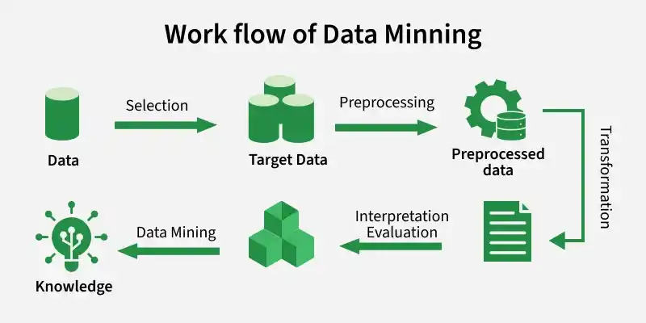
Simple Definition
Data mining means digging useful knowledge from data.
Just like mining gold from earth, data mining extracts valuable insights from large data.

2. Data Mining in MIS
In MIS, data mining helps managers answer questions such as:

Business Question | Data Mining Output
Which customers may leave? | Churn prediction
Which students may fail? | Academic risk prediction
Which product sells together? | Association pattern
Which transaction is suspicious? | Fraud detection
Which branch performs best? | Performance grouping
What will be next month’s sales? | Forecasting

3. Data Mining Process
Data Collection
↓
Data Cleaning
↓
Data Selection
↓
Data Transformation
↓
Data Mining
↓
Pattern Discovery
↓
Interpretation
↓
Decision-Making
4. Data Mining Techniques with Examples
4.1 Classification
Classification assigns data into predefined categories.
Example: Student Risk Classification
Student | Attendance % | Internal Marks | LMS Login/Week | Category
Ram | 92 | 38 | 5 | Low Risk
Sita | 64 | 22 | 1 | High Risk
Hari | 80 | 34 | 4 | Low Risk
Gita | 55 | 18 | 0 | High Risk
Nabin | 72 | 26 | 2 | Medium Risk
Decision:
- High-risk students need counseling.
- Medium-risk students need monitoring.
- Low-risk students continue normally.
Use cases:
- Loan approval
- Spam detection
- Student pass/fail prediction
- Customer loyal/not loyal
4.2 Clustering
Clustering groups similar records together without predefined categories.
Example: Customer Segmentation
Customer | Monthly Spending | Visit Frequency | Cluster
C1 | 50,000 | 8 | Premium Customer
C2 | 5,000 | 2 | Low-Value Customer
C3 | 30,000 | 6 | Regular Customer
C4 | 4,000 | 1 | Low-Value Customer
C5 | 70,000 | 10 | Premium Customer
Decision:
Cluster | Business Action
Premium customer | Give loyalty card
Regular customer | Offer bundle package
Low-value customer | Send discount campaign

4.3 Association Rule Mining
Association rule mining finds relationships between items.
Example: Retail Basket Analysis
Customer | Items Bought
C1 | Rice, Oil, Lentil
C2 | Rice, Oil
C3 | Bread, Butter
C4 | Rice, Oil, Sugar
C5 | Bread, Butter, Jam
Pattern:
- Customers who buy rice often buy oil.
- Customers who buy bread often buy butter.
Decision:
- Place rice and oil nearby.
- Create rice + oil combo offer.
- Place bread and butter together.

4.4 Regression
Regression predicts numerical values.
Example: Advertisement and Sales

Advertisement Cost | Sales
10,000 | 80,000
20,000 | 150,000
30,000 | 230,000
40,000 | 310,000
Possible prediction:
If advertisement cost is Rs. 50,000, expected sales may be around Rs. 390,000.
Use cases:
- Sales forecasting
- Demand prediction
- Profit prediction
- Price estimation

4.5 Anomaly Detection
Anomaly detection finds unusual or suspicious records.
Example: Banking Transactions
Transaction | Amount | Location | Status
T1 | 2,000 | Butwal | Normal
T2 | 3,500 | Butwal | Normal
T3 | 1,800 | Bhairahawa | Normal
T4 | 250,000 | Unknown | Suspicious
Decision:
- Block transaction temporarily.
- Send OTP verification.
- Alert fraud monitoring team.

4.6 Forecasting
Forecasting predicts future values using past data.
Example: Monthly Admission Inquiry
Month | Inquiries
January | 80
February | 100
March | 130
April | 160
May | 200
Possible decision:
- Increase admission counselors in June.
- Start marketing campaign before peak admission season.
- Prepare more seats or sections.

5. Data Warehouse vs Data Mining
Basis | Data Warehouse | Data Mining
Meaning | Central storage of historical data | Process of finding patterns from data
Purpose | Store and organize data | Discover knowledge
Function | Integrates data | Analyzes data
Output | Reports, dashboards | Patterns, predictions, rules
Example | Student data warehouse | Predict students likely to fail
Role in BI | Foundation | Advanced analysis
Simple relation:
Data Warehouse stores data.
Data Mining discovers knowledge from that data.

6. Data Warehousing and Data Mining Together
They work together in MIS.
Operational Data
↓
Data Warehouse
↓
Data Mining
↓
Knowledge
↓
Decision
Example:
Stage | College Example
Operational data | Attendance, marks, LMS login
Data warehouse | Historical student performance database
Data mining | Identify students likely to fail
Knowledge | Low attendance + low LMS login = high risk
Decision | Provide tutorial and counseling

7. Full MIS Scenario: Student Dropout Prediction
Problem
A college notices some students are dropping out. Management wants to use MIS data to reduce dropout.

Step 1: Data Sources
Source | Data
Attendance system | Attendance percentage
Exam system | Internal marks
Finance system | Fee due
LMS system | Login activity
Counseling system | Student feedback

Step 2: Data Warehouse
Student | Attendance % | Internal Marks | Fee Due | LMS Login/Week | Dropout Status
S1 | 90 | 38 | No | 5 | No
S2 | 62 | 21 | Yes | 1 | Yes
S3 | 80 | 32 | No | 4 | No
S4 | 55 | 18 | Yes | 0 | Yes
S5 | 70 | 25 | No | 2 | No
S6 | 58 | 20 | Yes | 1 | Yes

Step 3: Data Mining Pattern
Pattern Found | Meaning
Attendance below 65% | High dropout risk
Internal marks below 22 | Academic weakness
Fee due = Yes | Financial pressure
LMS login less than 2 | Low engagement

Step 4: Knowledge
Students with:
Attendance below 65%
+ Internal marks below 22
+ Fee due
+ Low LMS login
= Very high dropout risk

Step 5: Decision
Problem | Decision
Low attendance | Call parents and student
Low marks | Extra tutorial class
Fee due | Installment payment plan
Low LMS activity | Academic mentoring
High dropout risk | Counseling intervention

Step 6: Impact Measurement
Indicator | Before MIS Action | After MIS Action
Dropout rate | 15% | 7%
Average attendance | 72% | 84%
Internal pass rate | 78% | 90%
LMS activity | 45% active | 75% active
This shows how data warehousing and data mining support decision-making.

8. Business Benefits
Benefits of Data Warehousing
Benefit | Explanation
Centralized data | All data in one place
Historical analysis | Compare past and present
Better reporting | Faster dashboards
Consistency | Same data for all departments
Strategic planning | Supports long-term decisions

Benefits of Data Mining
Benefit | Explanation
Pattern discovery | Finds hidden relationships
Prediction | Forecasts future outcomes
Customer understanding | Identifies customer segments
Fraud detection | Finds abnormal activities
Competitive advantage | Enables smarter decisions

5.3 Business intelligence tools and techniques

In MIS, BI helps managers answer questions like:
- What happened?
- Why did it happen?
- What is happening now?
- What may happen in the future?
- What decision should we take?

1. Meaning of Business Intelligence
Business Intelligence is the process of converting raw business data into meaningful information, knowledge, dashboards, reports, and insights for managerial decision-making.
Simple flow:
Raw Data
↓
Data Cleaning
↓
Data Warehouse / Database
↓
Analysis
↓
Reports / Dashboards
↓
Decision-Making

Example:
Raw Data | BI Output | Managerial Decision
Daily sales data | Monthly sales dashboard | Increase stock of best-selling product
Customer complaints | Complaint trend report | Improve service department
Student attendance | Risk student report | Provide counseling
Hospital patient flow | Waiting-time dashboard | Add staff in OPD
Website clicks | Conversion analysis | Improve online marketing

2. Why BI Tools Are Needed
Without BI tools, data remains scattered in Excel files, databases, registers, and different systems. BI tools help combine and analyze that data.
Problem Without BI | Solution With BI
Data scattered in many systems | Integrates data in one platform
Manual report preparation | Automated dashboards
Slow decision-making | Faster real-time insights
Hard to identify trends | Visual charts and KPIs
Data duplication and errors | Data cleaning and validation
Guess-based decision | Evidence-based decision

3. Common Business Intelligence Tools
3.1 Microsoft Excel
Excel is one of the most common BI tools for basic analysis.
Uses
- Data entry
- Sorting and filtering
- Pivot table
- Charts
- Basic statistics
- Dashboard preparation
Example
A sales manager has this data:
Branch | Product | Sales
Butwal | Laptop | 300,000
Butwal | Mouse | 40,000
Bhairahawa | Laptop | 250,000
Bhairahawa | Keyboard | 60,000
In Excel, the manager can create:
- Pivot table by branch
- Bar chart by product
- Total sales calculation
- Branch-wise comparison

3.2 Microsoft Power BI
Power BI is a professional BI tool used for dashboards and interactive reports.
Uses
- Connect to Excel, SQL, web, cloud, API
- Create interactive dashboards
- Use slicers and filters
- Build KPI cards
- Share reports online
Example Dashboard KPIs
KPI | Value
Total Sales | Rs. 1,500,000
Total Profit | Rs. 420,000
Best Branch | Butwal
Best Product | Laptop
Customer Growth | 18%
Decision:
Management can quickly see which branch and product are performing better.

3.3 Tableau
Tableau is used for advanced and beautiful data visualization.
Uses
- Interactive visualization
- Drag-and-drop dashboard
- Storytelling with data
- Geographic map analysis
- Business trend analysis
Example:
A telecom company can use Tableau to show:
Analysis | Visualization
Customer location | Map
Monthly revenue | Line chart
Package subscription | Bar chart
Customer churn | Heatmap

3.4 Google Looker Studio
Google Looker Studio is a web-based dashboard tool.
Uses
- Website analytics dashboard
- Google Sheets dashboard
- Marketing report
- Campaign performance report
- Free dashboard sharing
Example:
A digital marketing team can connect Google Analytics data and create a report showing:
- Website visitors
- Page views
- Conversion rate
- Traffic source
- Campaign performance

3.5 SQL
SQL, Structured Query Language, is used to retrieve and analyze data from databases.
Example SQL Query
SELECT branch, SUM(sales) AS total_sales
FROM sales_data
GROUP BY branch;
Output:
Branch | Total Sales
Butwal | 500,000
Bhairahawa | 350,000
Palpa | 220,000
Decision:
Butwal branch is performing best.

3.6 Python
Python is used for advanced analytics, machine learning, prediction, and automation.
Common Python Libraries
Library | Use
Pandas | Data cleaning and analysis
NumPy | Numerical calculation
Matplotlib | Visualization
Scikit-learn | Machine learning
Seaborn | Statistical visualization
Plotly | Interactive charts

Example use:
- Predict sales
- Classify customers
- Detect fraud
- Analyze student performance
- Build recommendation system

3.7 R Programming
R is used for statistical analysis and research-based analytics.
Uses
- Statistical modeling
- Forecasting
- Research data analysis
- Visualization
- Survey analysis
Example:
MBA researchers may use R to analyze survey data on customer satisfaction.

3.8 Enterprise BI Tools
Tool | Common Use
SAP BusinessObjects | Enterprise reporting
IBM Cognos | Corporate BI and analytics
Qlik Sense | Interactive BI dashboards
Oracle BI | Enterprise data analysis
SAS BI | Statistical and predictive analytics

4. Business Intelligence Techniques
BI tools are software, while BI techniques are the methods used to analyze and present data.

Technique 1: Reporting
Reporting means preparing structured information from business data.
Types of Reports
Report Type | Example
Daily report | Daily sales report
Monthly report | Monthly profit report
Exception report | Stock below reorder level
Comparative report | This year vs last year
Summary report | Branch-wise total sales

Example Report
Month | Sales | Expense | Profit
January | 500,000 | 350,000 | 150,000
February | 600,000 | 390,000 | 210,000
March | 750,000 | 480,000 | 270,000
Decision:
Sales and profit are increasing, so business can plan expansion.

Technique 2: Dashboard
A dashboard is a visual screen showing important business indicators.
Dashboard Example
KPI | Value
Total Revenue | Rs. 2,500,000
Total Expense | Rs. 1,700,000
Net Profit | Rs. 800,000
Profit Margin | 32%
Best Product | Laptop
Best Branch | Butwal

A dashboard helps managers understand business condition quickly.

Technique 3: KPI Analysis
KPI means Key Performance Indicator.
KPI measures whether the organization is achieving its goals.
Examples of KPIs
Business Area | KPI
Sales | Monthly sales growth
Finance | Profit margin
HR | Employee attendance
Education | Pass percentage
Hospital | Patient waiting time
E-commerce | Conversion rate
Inventory | Stock turnover
Example
KPI | Target | Actual | Status
Monthly Sales | 1,000,000 | 1,200,000 | Achieved
Profit Margin | 30% | 28% | Needs Improvement
Customer Satisfaction | 90% | 85% | Needs Improvement
Delivery Time | 2 days | 3 days | Delayed
Decision:
Sales target is achieved, but customer satisfaction and delivery time need improvement.

Technique 4: OLAP Analysis
OLAP means Online Analytical Processing.
It helps analyze data from multiple dimensions.
Example Dimensions
Sales can be analyzed by:
- Product
- Branch
- Month
- Customer type
- Salesperson
OLAP Table Example
Branch | Laptop Sales | Mobile Sales | Accessories | Total
Butwal | 500,000 | 300,000 | 100,000 | 900,000
Bhairahawa | 400,000 | 250,000 | 80,000 | 730,000
Palpa | 250,000 | 150,000 | 50,000 | 450,000
Manager can drill down:
- Sales by branch
- Sales by product
- Sales by month
- Sales by customer segment
The article also discusses OLAP as an important component of BI for analytical processing and reporting.

Technique 5: Data Visualization
Data visualization presents data using charts, graphs, maps, and dashboards.
Chart Selection
Question | Best Chart
Which product sells most? | Bar chart
How did sales change over time? | Line chart
What is market share? | Pie chart
Which region performs best? | Map chart
Is advertisement related to sales? | Scatter plot
Which branch has high/low performance? | Heatmap
Example
Product | Sales
Laptop | 900,000
Mobile | 700,000
Mouse | 120,000
Keyboard | 150,000
A bar chart will clearly show that laptop has the highest sales.

Technique 6: Drill-Down Analysis
Drill-down means moving from summary data to detailed data.
Example
First level:
Year | Sales
2026 | 12,000,000
Drill down by month:
Month | Sales
January | 900,000
February | 1,000,000
March | 1,300,000
Drill down by branch:
Branch | March Sales
Butwal | 600,000
Bhairahawa | 450,000
Palpa | 250,000
Decision:
March sales increased mainly because Butwal branch performed well.

Technique 7: Slice and Dice
Slice and dice means viewing data from different angles.
Example Dataset
Month | Branch | Product | Sales
Jan | Butwal | Laptop | 300,000
Jan | Butwal | Mobile | 200,000
Jan | Bhairahawa | Laptop | 250,000
Feb | Butwal | Laptop | 350,000
Feb | Bhairahawa | Mobile | 220,000
Slice
Only view Butwal data.
Month | Product | Sales
Jan | Laptop | 300,000
Jan | Mobile | 200,000
Feb | Laptop | 350,000
Dice
View Butwal + Laptop + February.
Month | Branch | Product | Sales
Feb | Butwal | Laptop | 350,000

Technique 8: Data Mining
Data mining discovers hidden patterns from large datasets.
Data Mining Techniques

Technique | Use
Classification | Predict category
Clustering | Group similar customers
Association rule | Find items bought together
Regression | Predict numerical value
Anomaly detection | Detect unusual behavior
Example
Retail basket data:
Customer | Items Bought
C1 | Rice, Oil
C2 | Rice, Oil, Sugar
C3 | Bread, Butter
C4 | Rice, Oil
C5 | Bread, Butter, Jam
Pattern:
Customers who buy rice often buy oil.
Decision:
Place rice and oil together or offer combo discount.

Technique 9: Predictive Analytics
Predictive analytics uses past data to forecast future outcomes.
Example
Month | Sales
January | 500,000
February | 600,000
March | 700,000
April | 850,000
Prediction:
May sales may reach around Rs. 950,000.
Decision:
- Increase stock before May.
- Hire temporary staff.
- Prepare marketing campaign.

Technique 10: Prescriptive Analytics
Prescriptive analytics suggests what action should be taken.
Example

Situation | Prescriptive Recommendation
Stock is low and demand is high | Reorder immediately
Customer may leave | Send loyalty offer
Student is high-risk | Provide counseling
OPD waiting time high | Add doctor in peak hours
Delivery delay increasing | Add delivery staff
Predictive analytics says:
What may happen?
Prescriptive analytics says:
What should we do?

5. Types of Analytics in BI
Type | Question Answered | Example
Descriptive analytics | What happened? | Last month sales were Rs. 10 lakh
Diagnostic analytics | Why did it happen? | Sales increased due to festival offer
Predictive analytics | What will happen? | Next month sales may be Rs. 12 lakh
Prescriptive analytics | What should we do? | Increase inventory and marketing

5.4 Big data analytics and its business applications

1. Meaning of Big Data
Big Data refers to extremely large, fast, and complex data that cannot be easily managed by traditional database systems.
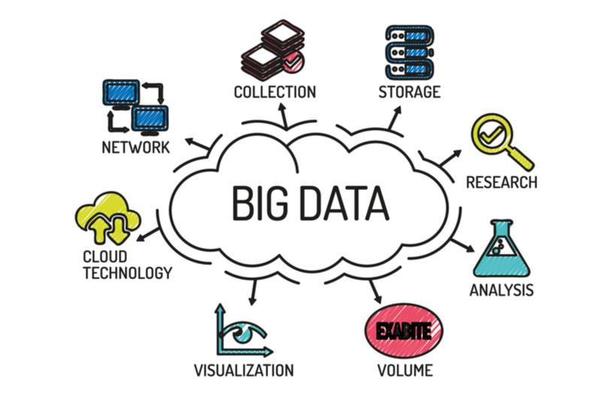
Examples:
Source | Big Data Example
Social media | Likes, comments, shares
E-commerce | Clicks, orders, searches
Banking | ATM, mobile banking, transactions
Hospital | Patient records, lab reports
IoT devices | Sensors, GPS, smart devices
Telecom | Call records, internet usage
The BI article explains that modern BI systems may include structured, semi-structured, unstructured, streaming, and external data sources for decision-making.

2. 5 Vs of Big Data
V | Meaning | Example
Volume | Huge amount of data | Millions of transactions
Velocity | Fast data generation | Live online orders
Variety | Different data formats | Text, image, video, database
Veracity | Data quality/trust | Fake reviews, duplicate data
Value | Useful business benefit | Better customer recommendation

3. Big Data Analytics
Big Data Analytics means analyzing large and complex datasets to find patterns, trends, predictions, and useful insights.
Simple flow:
Big Data Sources
↓
Storage
↓
Processing
↓
Analytics
↓
Dashboard / Report
↓
Business Decision

The uploaded article discusses big data architecture with data sources, storage, batch processing, stream processing, analytical data store, analytics, and reporting.

4. Batch and Stream Processing
Type | Meaning | Example
Batch Processing | Data processed in groups | Monthly sales report
Stream Processing | Data processed continuously | Live fraud detection
Example:
A bank may use stream processing to detect suspicious transactions immediately.

5. Big Data Tools
Tool | Use
Hadoop | Store and process large data
Spark | Fast big data processing
Kafka | Real-time data streaming
MongoDB | Store flexible document data
Cassandra | Distributed big data storage
Python | Data analysis and machine learning
Power BI/Tableau | Dashboard and visualization


6. Business Applications of Big Data Analytics
A. E-Commerce
Big data helps online businesses understand customer behavior.
Data | Use
Search history | Product recommendation
Cart abandonment | Send discount offer
Reviews | Product improvement
Clicks | Website design improvement
Example decision:
If many customers add products to cart but do not buy, the company can send reminder messages or discount coupons.

B. Banking and Finance
Data | Use
Transaction history | Fraud detection
Loan records | Credit scoring
Customer spending | Personalized banking offer
Example:
If a customer usually transacts in Butwal but suddenly makes a large transaction from another country, the system may mark it suspicious.

C. Healthcare
Data | Use
Patient records | Diagnosis support
Lab reports | Disease prediction
Hospital visit data | Resource planning
Wearable data | Health monitoring
Example:
Hospital can predict peak OPD hours and assign more doctors.

D. Education
Data | Use
Attendance | Identify irregular students
Exam marks | Find weak students
LMS login | Measure student engagement
Assignment submission | Predict performance
Example:
A college can identify students at dropout risk using attendance, marks, and LMS activity.

E. Retail Business
Data | Use
Sales data | Demand forecasting
Customer data | Loyalty program
Inventory data | Stock planning
Purchase pattern | Combo offers
Example:
If rice and oil are often bought together, the store can create a rice-oil bundle offer.

F. Transportation and Logistics
Data | Use
GPS data | Route optimization
Delivery time | Performance tracking
Fuel usage | Cost reduction
Traffic data | Faster delivery planning
Example:
A delivery company can choose the shortest route using GPS and traffic data.

7. Benefits of Big Data Analytics
Benefit | Explanation
Better decisions | Uses facts and patterns
Faster response | Real-time analysis
Cost reduction | Detects waste and inefficiency
Customer satisfaction | Personalized service
Risk control | Fraud and error detection
Competitive advantage | Smarter and faster business strategy
8. Challenges of Big Data
Challenge | Explanation
Data privacy | Sensitive data must be protected
Data quality | Wrong data gives wrong analysis
High cost | Tools and infrastructure may be expensive
Skilled manpower | Needs trained analysts
Security risk | Large data can attract cyberattacks
Integration issue | Data comes from many sources

